**Project Design Phase-II Technology Stack (Architecture & Stack)**

|  |  |
| --- | --- |
| Date | 16 October 2022 |
| Team ID | PNT2022TMID02471 |
| Project Name | IOT BASED SMART CROP PROTECTION SYSTEM |
| Maximum Marks | 4 Marks |

**Technical Architecture:**

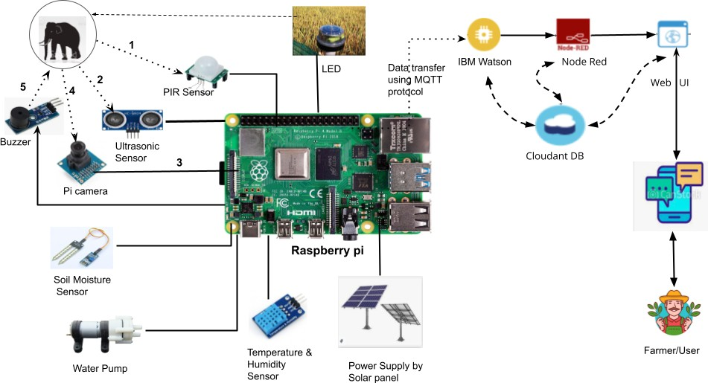

Table-1 : Components & Technologies:

|  |  |  |  |
| --- | --- | --- | --- |
| **S.No** | **Component** | **Description** | **Technology** |
| 1 | User Interface | How user interacts with application e.g. Web UI, Mobile App, Chatbot etc. | HTML, CSS, JavaScript / Angular Js / React Js etc. |
| 2 | Application Logic-1 | Logic for a process in the application | Java / Python |
| 3 | Application Logic-2 | Logic for a process in the application | IBM Watson IOT service |
| 4 | Application Logic-3 | Logic for a process in the application | IBM Watson Assistant |
| 5 | Application Logic-3 | Logic for a process in the application | Node-RED for wiring together hardware devices, APIs and online  services |
| 6 | Database | Data Type, Configurations etc. | MySQL, NoSQL, etc. |
| 7 | Cloud Database | Database Service on Cloud | IBM DB2, IBM Cloudant etc. |
| 8 | File Storage | File storage requirements | IBM Block Storage or Other Storage  Service or Local Filesystem |
| 9 | External API-1 | Purpose of External API used in the application | IBM Weather API, etc. |
| 10 | External API-2 | Purpose of External API used in the application | Aadhar API, etc. |
| 11 | Machine Learning Model | Purpose of Machine Learning Model | Object Recognition Model, Image Processing Model etc. |
| 12 | Infrastructure (Server / Cloud) | Application Deployment on Local System / Cloud Local Server Configuration  Cloud Server Configuration | Local, Cloud Foundry, Kubernetes, etc. |
| 13 | Microprocessor used | kind of device used for processing | Raspberry Pi, Arduino etc |

|  |  |  |  |
| --- | --- | --- | --- |
| 14 | Various Sensor Used | Devices used for measuring the surrounding environment | Soil Moisture Sensor,Temperature & Humidity Sensor,PIR  Sensor,UltraSonic Sensor |
| 15 | Power Supply | For Energizing the Microprocessor,Sensor &  Actuator | Solar Panel is used as Power Supply |
| 16 | Communication Gateway | For transferring information from Device to Cloud | In built Wifi module in Raspberry pi |
| 17 | Computer Vision | For Classifying Threatened Animals And Alert the Farmers | image Processing Module OpenCV with python |
| 18 | Various Actuator Components | For irrigating the farms and to Drive Away Cattles &  Trespassed animals | Water pump,buzzer and led lights |
| 19 | Communication Protocol | For transferring information from various client to server and then to particular client | MQTT Protocol (MQTT publisher & MQTT Broker-IBM Watson) |

Table-2: Application Characteristics:

|  |  |  |  |
| --- | --- | --- | --- |
| **S.No** | **Characteristics** | **Description** | **Technology** |
| 1. | Open-Source Frameworks | List the open-source frameworks used | Technology of OpenSource framework |
| 2. | Security Implementations | List all the security / access controls implemented, use of firewalls etc. | e.g. SHA-256, Encryptions, IAM Controls, OWASP etc. |
| 3. | Scalable Architecture | Justify the scalability of architecture (3 – tier,  Micro-services) | Technology used |
| 4. | Availability | Justify the availability of application (e.g. use of load balancers, distributed servers etc.) | Technology used |
| 5. | Performance | Design consideration for the performance of the application (number of requests per sec, use of  Cache, use of CDN’s) etc. | Technology used |

PNT2022TMID38540